**Graffiti Grouping/Routing Project**

The DSNY exports a list of graffiti spots (around 450) to be cleaned every two weeks. We are exploring possible approaches to optimizing current GIS steps that calculate efficient routes in five boroughs.

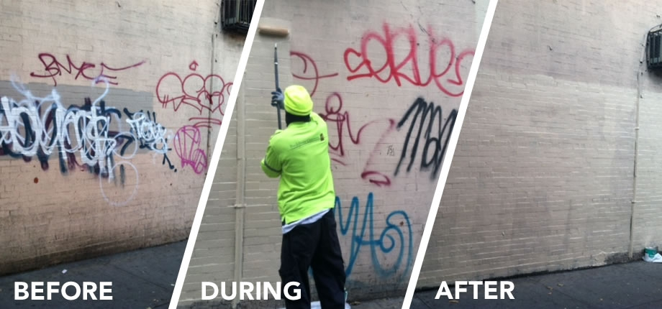

**Current Steps (using GIS):**

1. Data Preparation (X/Y coordinates)

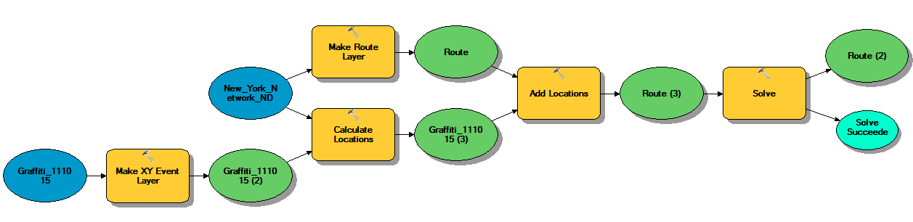2. Network Calculation (Traveling Salesman Problem)

3. Manual Grouping (10 per group, separate borough spots)

4. Final Edits (rename boroughs & columns, combine address, export to excel)

**Current problems:** time-consuming, subjective grouping, inefficient network calculation

**Revised Steps (using Python):**

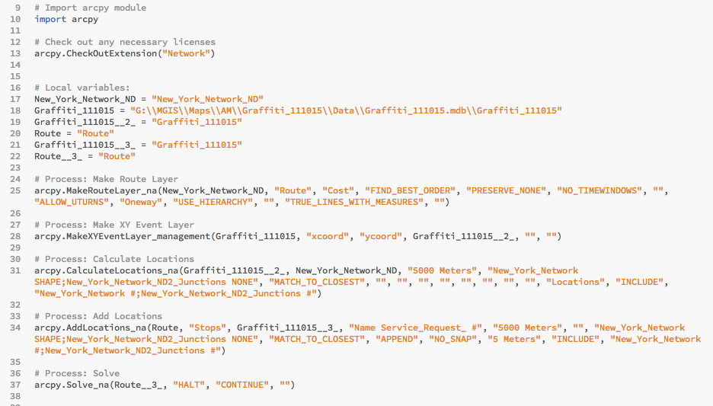

1. Data Preparation (X/Y coordinates)

2. Grouping by Boroughs (BK+SI if SI < 8)

3. *Network as Distance (without sequence)

4. Grouping by median center/mean center/clustering/the next closest spot (10 per group)

5. Final Edits (rename and combine, export to excel/csv)